**Assignment 3**

|  |  |
| --- | --- |
| Team ID | **PNT2022TMID19214** |

1.Create a bucket in ibm cloud storage

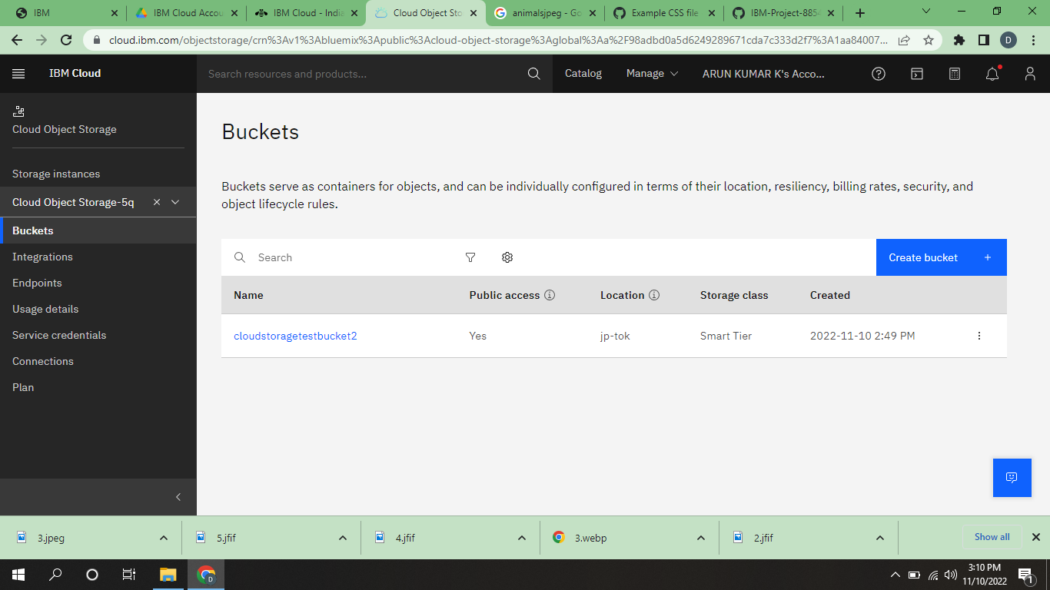

2.Upload an 5 images to IBM object storage and make it public. Write html code to displaying all the 5 images.

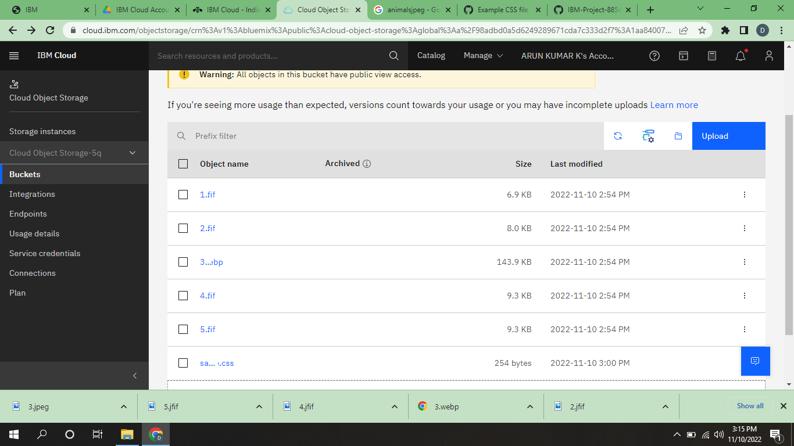

HTML Code to display the images in IBM Object Storage.

3.Upload a css page to the object storage and use the same page in your HTML code.

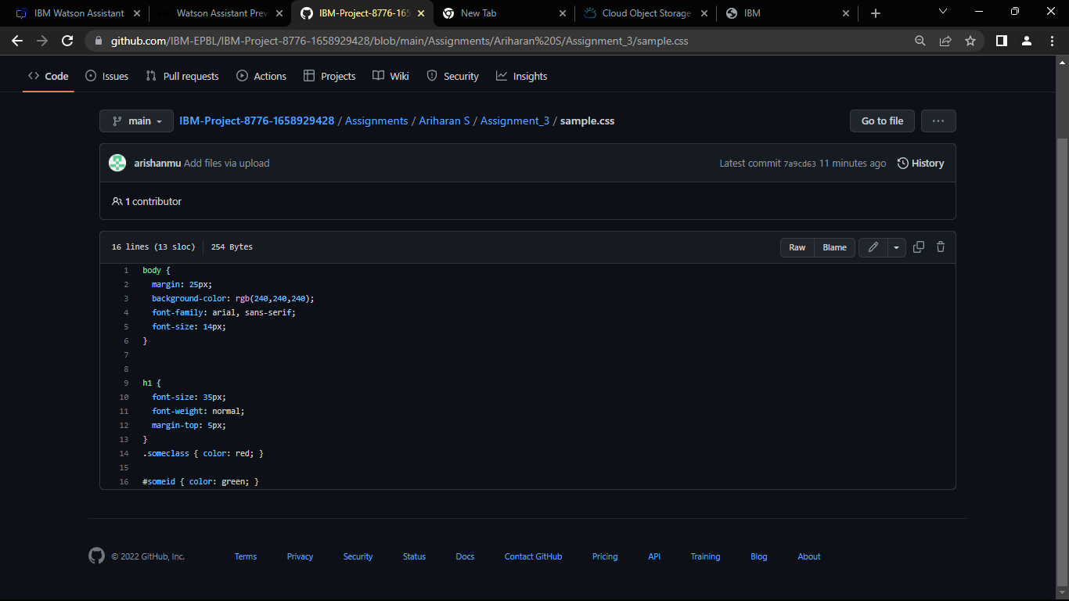

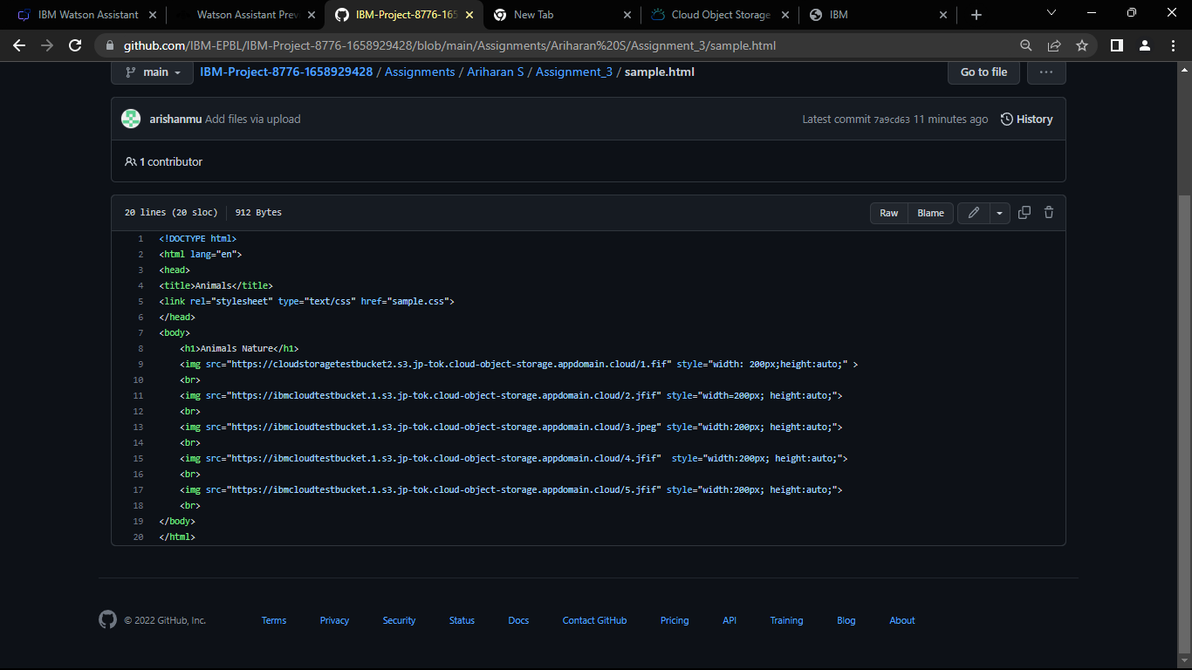

4.Design a chatbot using IBM Watson assistant for hospital. Ex: User comes with query to know the branches for that hospital in your city. Submit the web URL of that chat bot as a assignment.

Link: https://web-chat.global.assistant.watson.appdomain.cloud/preview.html?backgroundImageURL=https%3A%2F%2Fau-syd.assistant.watson.cloud.ibm.com%2Fpublic%2Fimages%2Fupx-4ad2703f-45b1-4d6c-9672-23c91da74f05%3A%3Adaf65bc7-3cc3-4ba1-9c0f-1096f745962d&integrationID=46704013-a97d-4a0b-9ff3-ae27526ef0dd&region=au-syd&serviceInstanceID=4ad2703f-45b1-4d6c-9672-23c91da74f05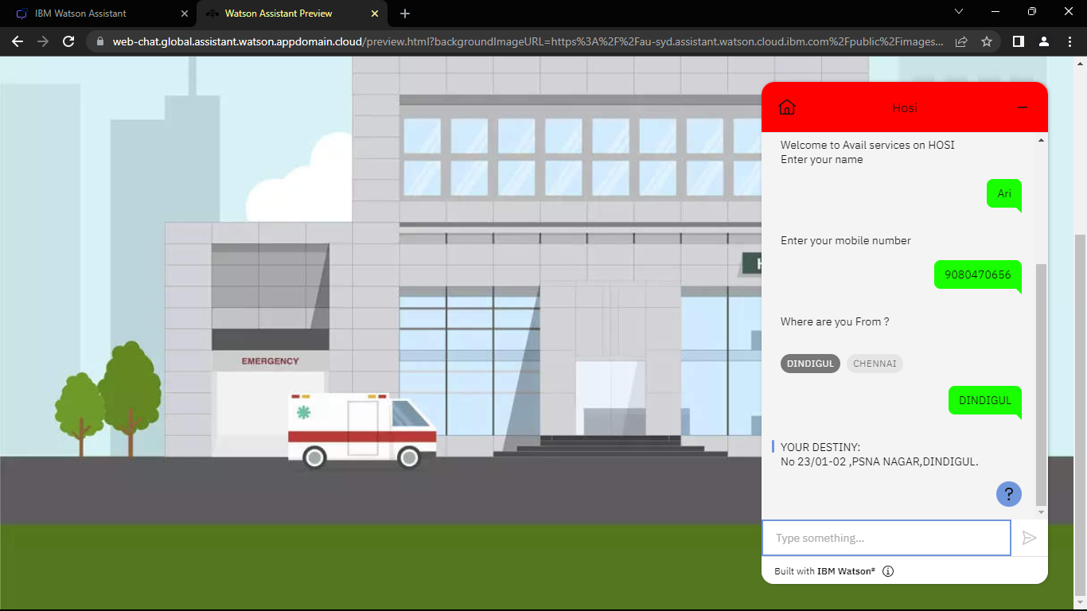

5.Create Watson assistant service with 10 steps and use 3 conditions in it. Load that script in HTML page

<!DOCTYPE html>

<html>

<head>

<title>Chatbot example Website</title>

<link rel="stylesheet" type="text/css" href="https://cloudstoragetestbucket2.s3.jp-tok.cloud-object-storage.appdomain.cloud/sample.css">

<link rel="preconnect" href="https://fonts.gstatic.com">

<link href="https://fonts.googleapis.com/css2?family=Josefin+Sans:ital,wght@0,100;0,200;0,300;0,400;0,500;0,600;0,700;1,100;1,200;1,300;1,400;1,500;1,600;1,700&display=swap" rel="stylesheet">

<link rel="stylesheet" href="https://cdnjs.cloudflare.com/ajax/libs/font-awesome/5.15.3/css/all.min.css" integrity="sha512-iBBXm8fW90+nuLcSKlbmrPcLa0OT92xO1BIsZ+ywDWZCvqsWgccV3gFoRBv0z+8dLJgyAHIhR35VZc2oM/gI1w==" crossorigin="anonymous" referrerpolicy="no-referrer" />

<script>

window.watsonAssistantChatOptions = {

integrationID: "46704013-a97d-4a0b-9ff3-ae27526ef0dd", // The ID of this integration.

region: "au-syd", // The region your integration is hosted in.

serviceInstanceID: "4ad2703f-45b1-4d6c-9672-23c91da74f05", // The ID of your service instance.

onLoad: function(instance) { instance.render(); }

};

setTimeout(function(){

const t=document.createElement('script');

t.src="https://web-chat.global.assistant.watson.appdomain.cloud/versions/" + (window.watsonAssistantChatOptions.clientVersion || 'latest') + "/WatsonAssistantChatEntry.js";

document.head.appendChild(t);

});

</script>

</head>

<body>

<div class="hero">

<nav>

<h2 class="logo">Hi<span> Everyone</span></h2>

<a class="btn">Welcome to Hospital Management</a>

</nav>

</div>

</body>

</html>

